The Genetic algorithm is an adaptive heuristic search method based on population genetics. Genetic algorithms were introduced by John Holland in the early 1970s (14). Genetic algorithms (GAs) also implement the optimization strategies by simulating evolution of species through natural selections (4). Genetic algorithm is generally composed of two processes. First process is selection of individual for the production of next generation. Implementation of genetic algorithm begins with a population of chromosomes. One then evaluates these structures and allocated reproductive opportunities in such a way that these chromosomes which represent a better solution to the target problem are given more chances to ‘reproduce’ than those chromosomes which are poorer solutions. The ’goodness’ of a solution is typically defined with respect to the current population (18). And second process is manipulation of the selected individual to form the next generation by crossover and mutation techniques (4). A simple flowchart is illustrated in fig. 1 to help understand the steps in GAs.

Framework of Genetic Algorithm:

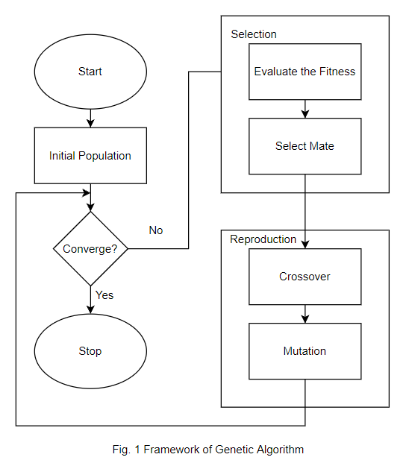

Initial population:

In GAs, the parameters of the search space are encoded in the form of strings (called chromosomes). A collection of such strings is called a population. Initially, a random population is created, which represents different points in the search space. An objective and fitness function is associated with each string that represents the degree of goodness of the string.

Selection:

There are various approaches suggested to select the parent’s string which may vary depending on the difficulty level of the problems. But, all in all making decision about appropriate selection method to be applied is considered as a difficult step and the same step is responsible for the speed of evolution and sometimes called as selection pressure. The different selection techniques applied in GA search process influences the overall performance (1). There are three Selection Techniques:

1. Tournament Selection
2. Roulette Wheel
3. Rank Based

Reproduction: The next step is evolution of next generation. To produce the next generation, a pair of ‘parent’ are selected from the population which are then bred through different processes that are:

(i)Crossover:

The generation of successors in a GA is determined by a set of operators that recombine and mutate selected members of the current population. The two most common operators are crossover and mutation. The crossover operator produces two new offspring from two parent strings, by copying selected bits from each parent. The bit at position i in each offspring is copied from the bit at position i in one of the two parents. The choice of which parent contributes the bit for position i is determined by an additional string called the crossover mask. Figure 3.10 below illustrates crossover operator briefly. There are three types of crossover operators, namely as single-point, two-point and uniform crossover (4).

(ii)Mutation:

The second protagonist in Genetic Algorithms is mutation. Mutation operators change a solution by disturbing them. Mutation is based on random changes. The strength of this disturbance is called mutation rate. In continuous solution spaces the mutation rate is also known as step size (8). There are three main requirements for mutation operators. They are: Reachability, unbiasedness, scalability.

Converge:

This generational process is repeated until a termination condition has been reached. Common terminating conditions are (14):

* A solution is found that satisfies minimum criteria;
* Fixed number of generations reached;
* Allocated budget (computation time/money) reached;
* The highest-ranking solution’s fitness is reaching or has reached a plateau such that successive iterations no longer produce better results;
* Manual inspection;
* Combinations of the above.

Simple Genetic algorithm pseudocodes:

1. Choose the initial population of individuals.
2. Evaluate the fitness of each individual in that population
3. Repeat on this generation until termination (14).

The main motive of this paper is towards the comparative analysis of different techniques used in the GAs.

Previous work:

Anupriya (1) had compared four selection techniques i.e., Proportionate Roulette Wheel Selection, Linear Ranking Selection, Exponential Ranking Selection, Tournament Selection where it was found that Tournament Selection was better in terms of convergence rate and time complexity.

Tiejun (3) had compared Tournament Selection, Roulette Selection, Elitist Selection, Mating Selection of different reviewers where Tournament Selection was the most common result(35.7%) followed by ranking Selection(28.6).

Brad (6) only focused on Tournament Selection on all types of data like Deterministic Environments, Noisy Environment and concluded that the model was verified to accurate for predicting the convergence rate under a wide range of levels and tournament sizes.

Selection Techniques:

1. Tournament Selection:

Tournament Selection is a selection technique that is used to select the fittest candidate among a small group of a population. The population is grouped into small groups and the fittest among each move to another generations. This process repeats until the fittest candidate is found among the given population and is passed along to the next generation.

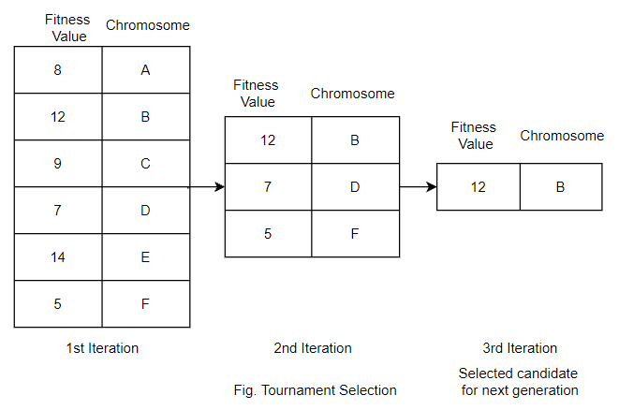

1. Roulette Wheel Selection

As the name suggests, a wheel is divided according to the fitness of the candidates and a point is fixed. Now the wheel is rotated, when the wheel stops the fixed point indicates the region of the selected candidate for next generation.

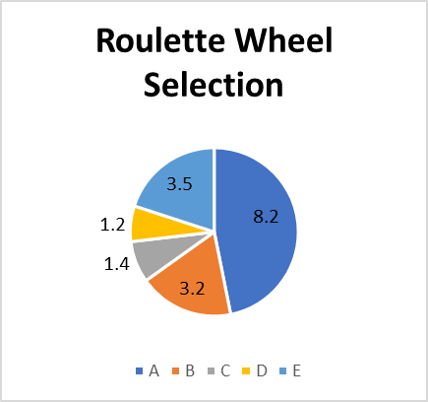

Fixed Point

1. Rank Based Selection

Rank Based Selection is same as Roulette wheel Selection but it is introduced to bring variety to the selection of chromosomes. In roulette wheel, the regions are based on the fitness value of the candidate which meant that candidate with higher fitness value have higher occurrence due to larger region. This meant other candidates could not be selected frequently resulting in less diversity. So, to overcome this issue, rank is given to the chromosomes. The chromosome with minimal fitness value is given rank 1 followed by the comparatively higher and so on. The chromosome with highest fitness is given the highest rank. Now, each region will have equal region resulting common occurrence to all.

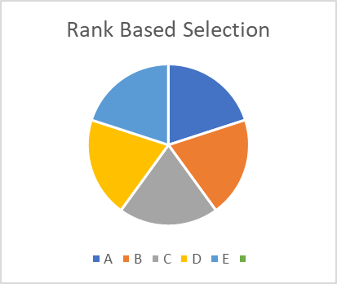

Fixed Point